Mobile App Changes

1. Landing Page

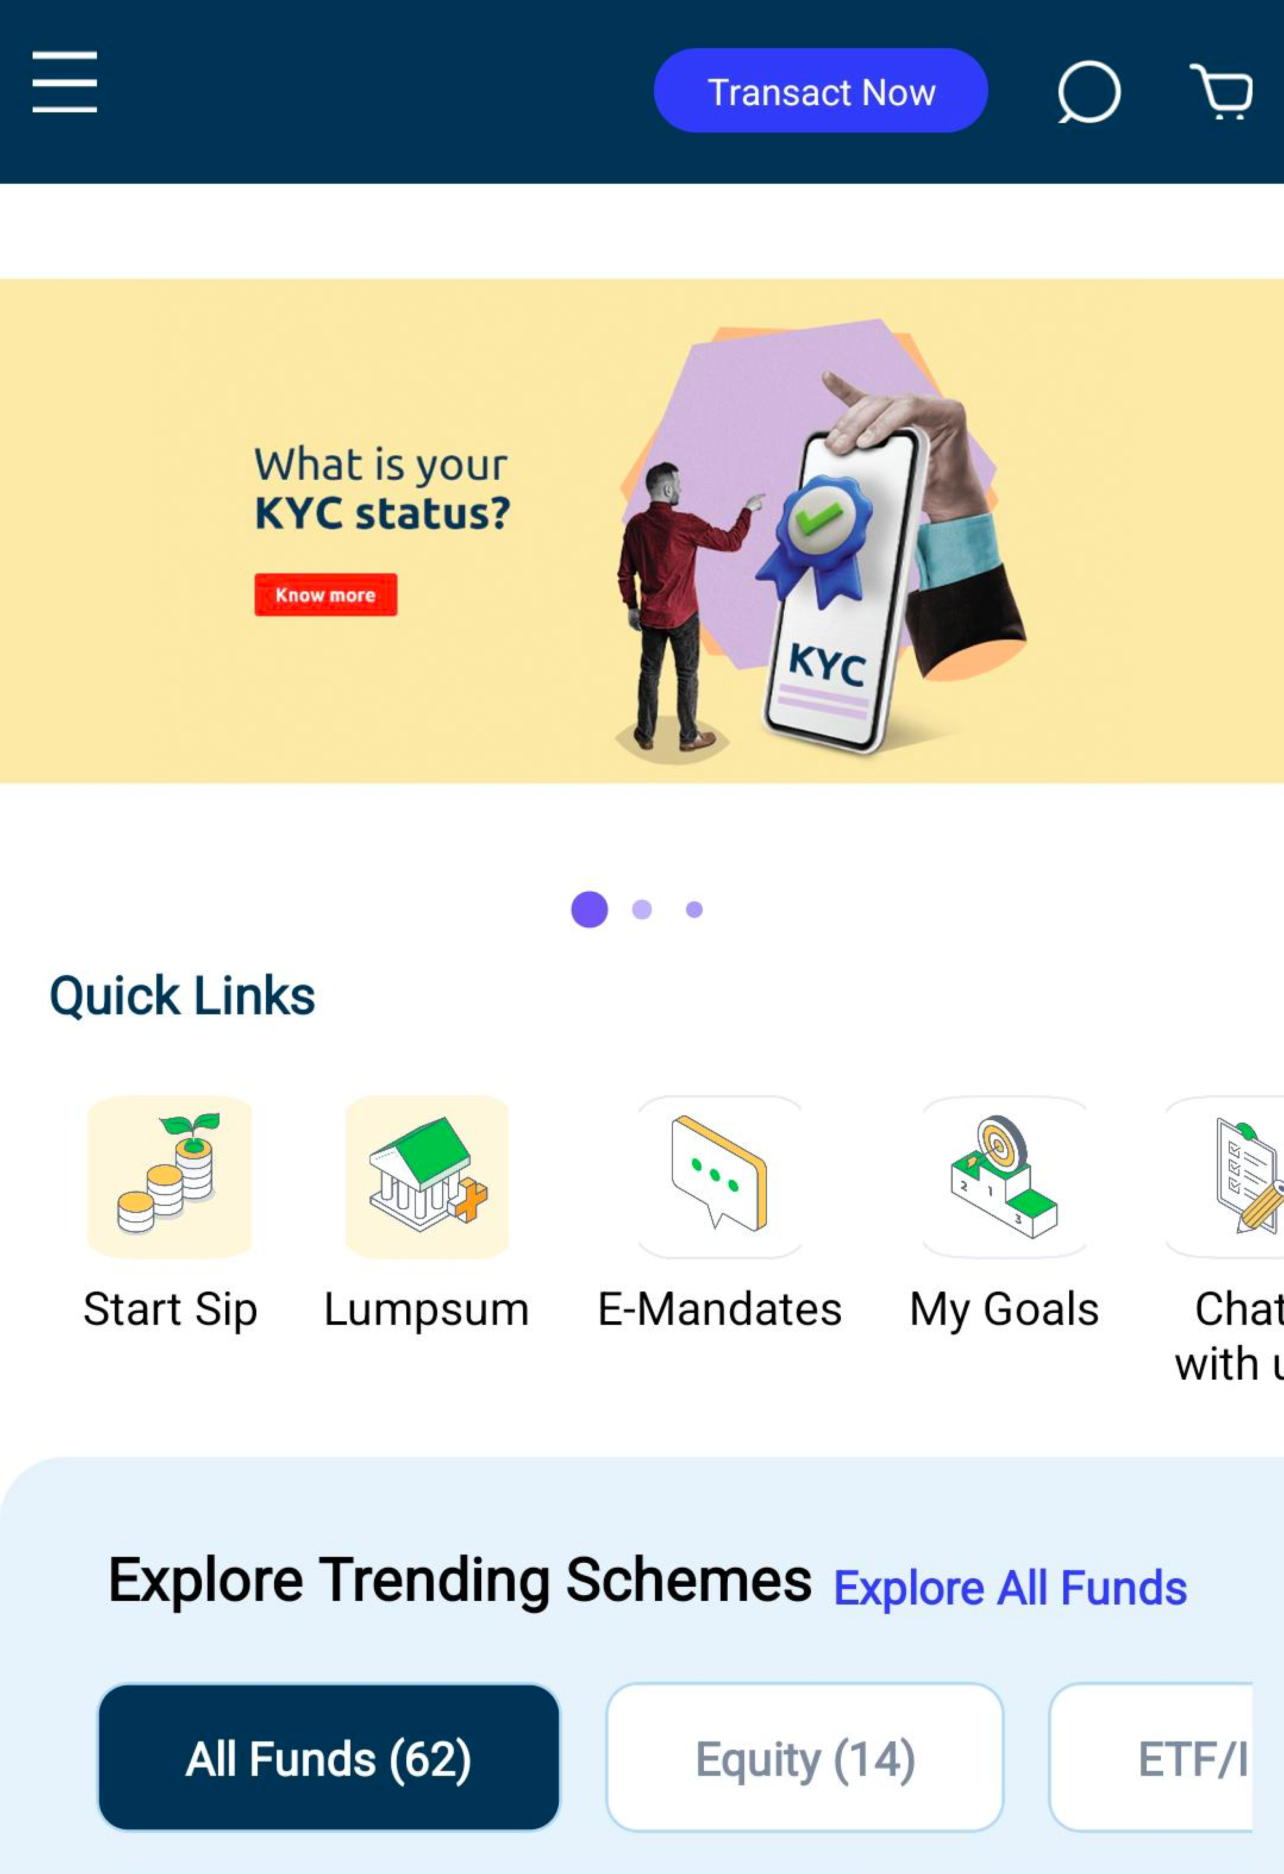

* Banner should be start from top nav
* Carousal circle should be small
* Font Size of heading of “Explore Trending Scheme”
* Chip Size should be small and their font size should be small
* Grid should start from Quick links
* Font size should be same of every heading

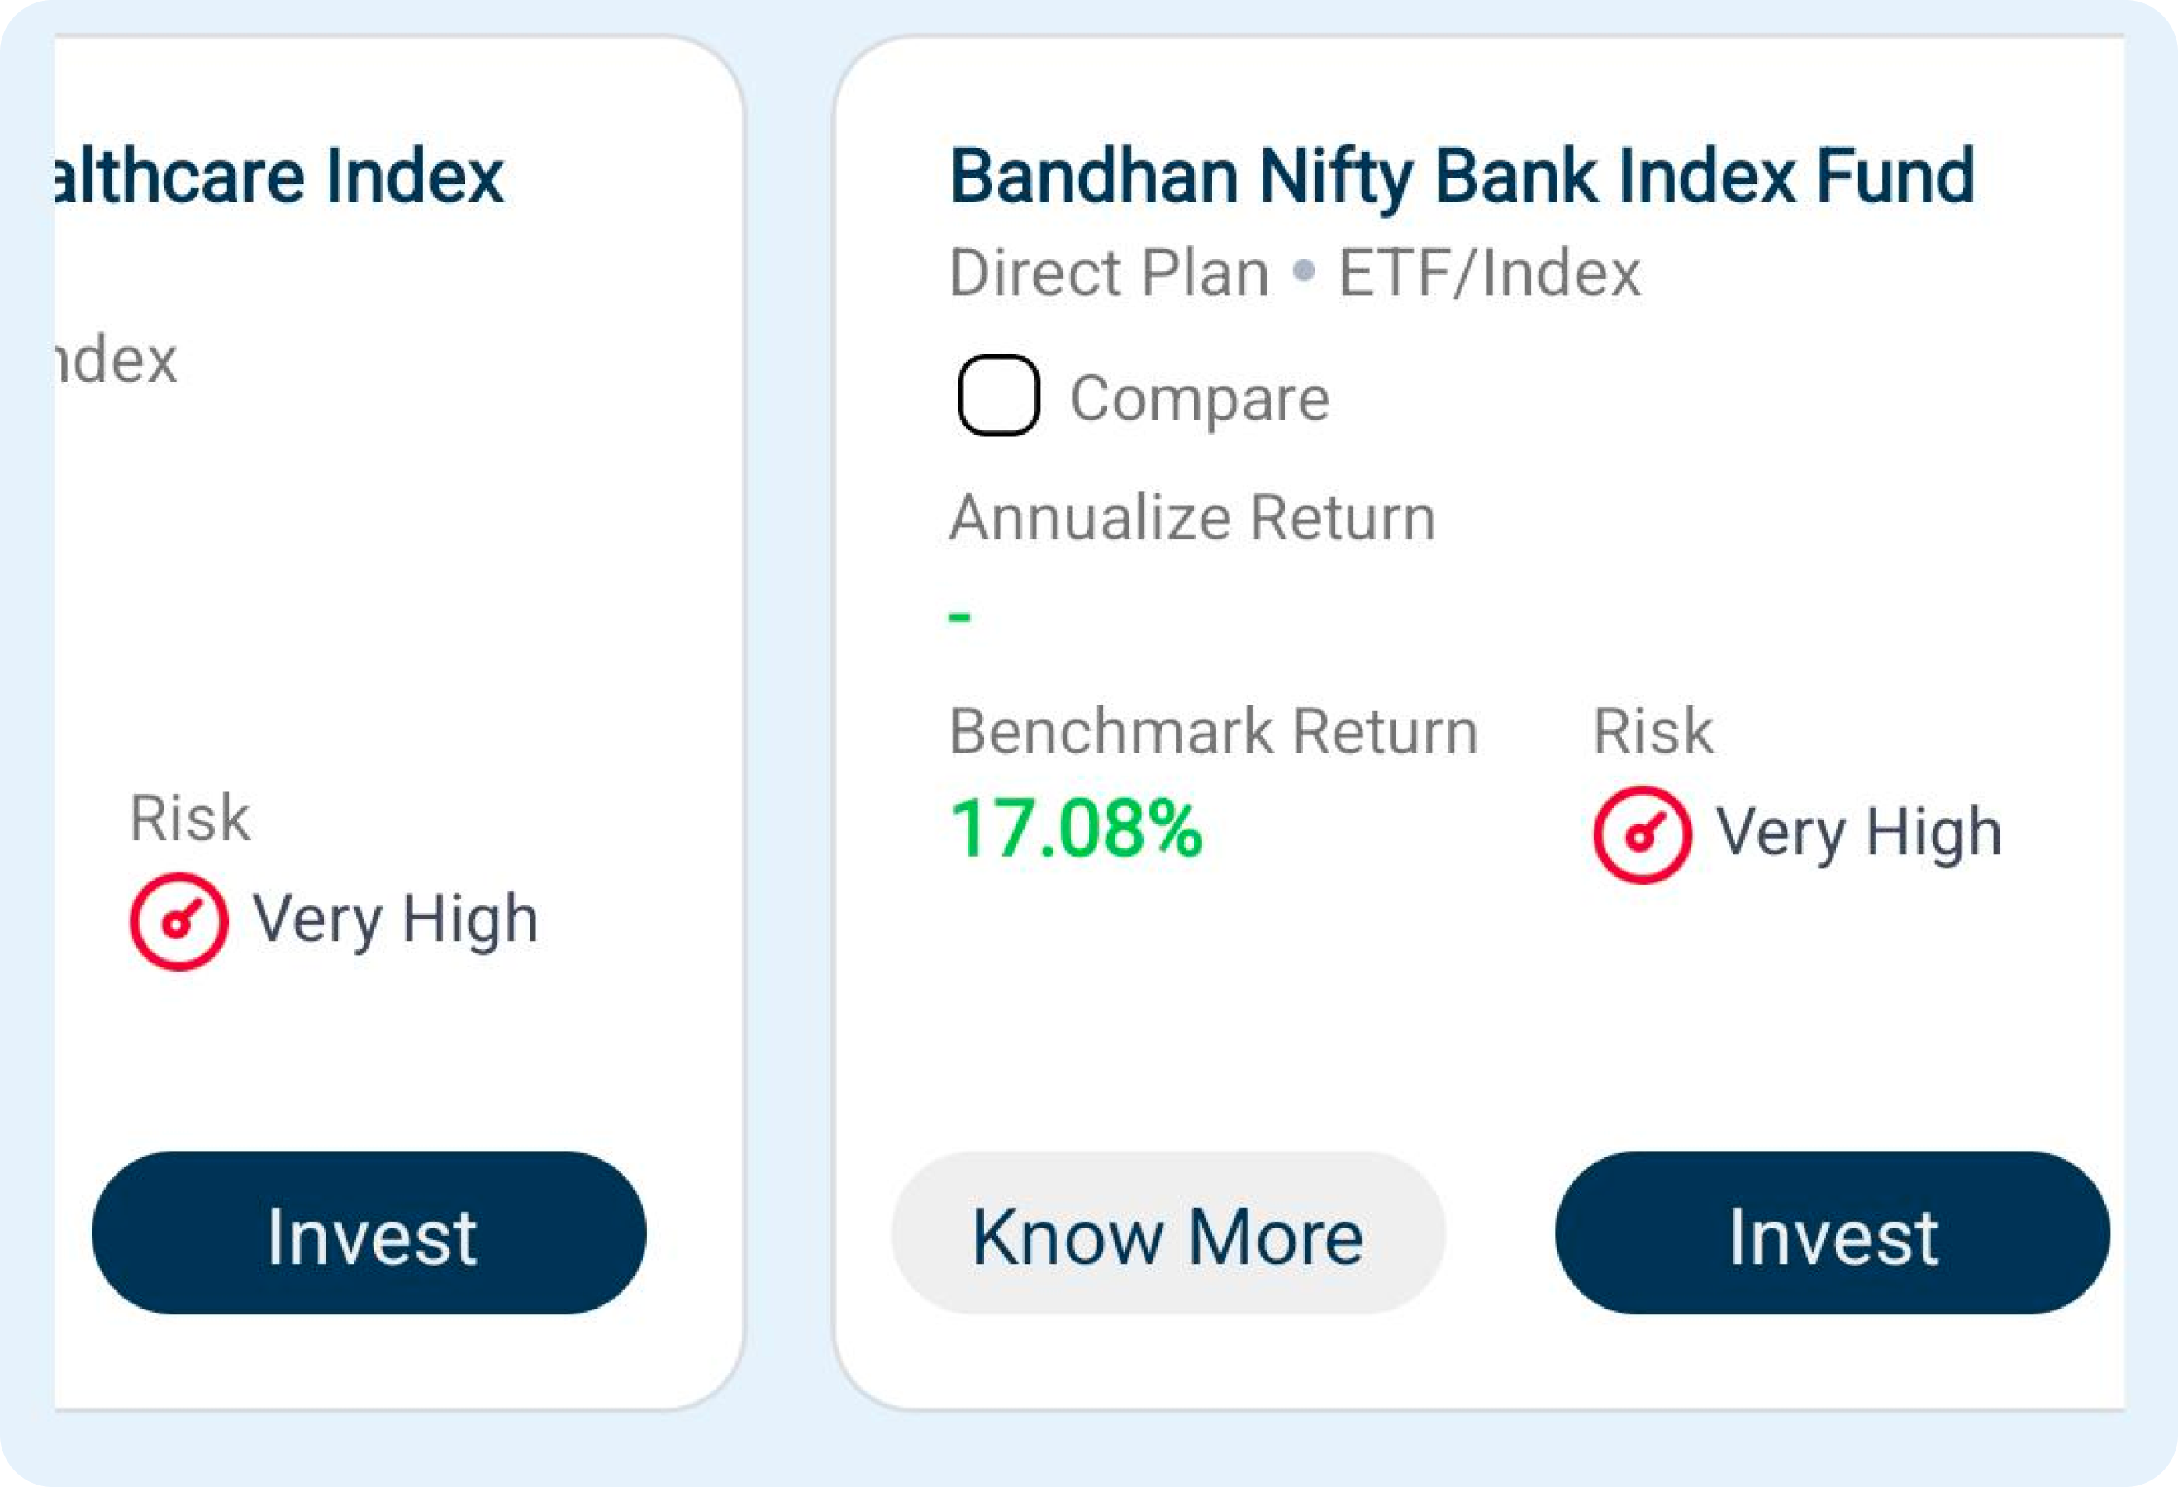

* Space between direct plan and scheme name
* increase Margin and Padding of primary and secondary button and reduce the font size

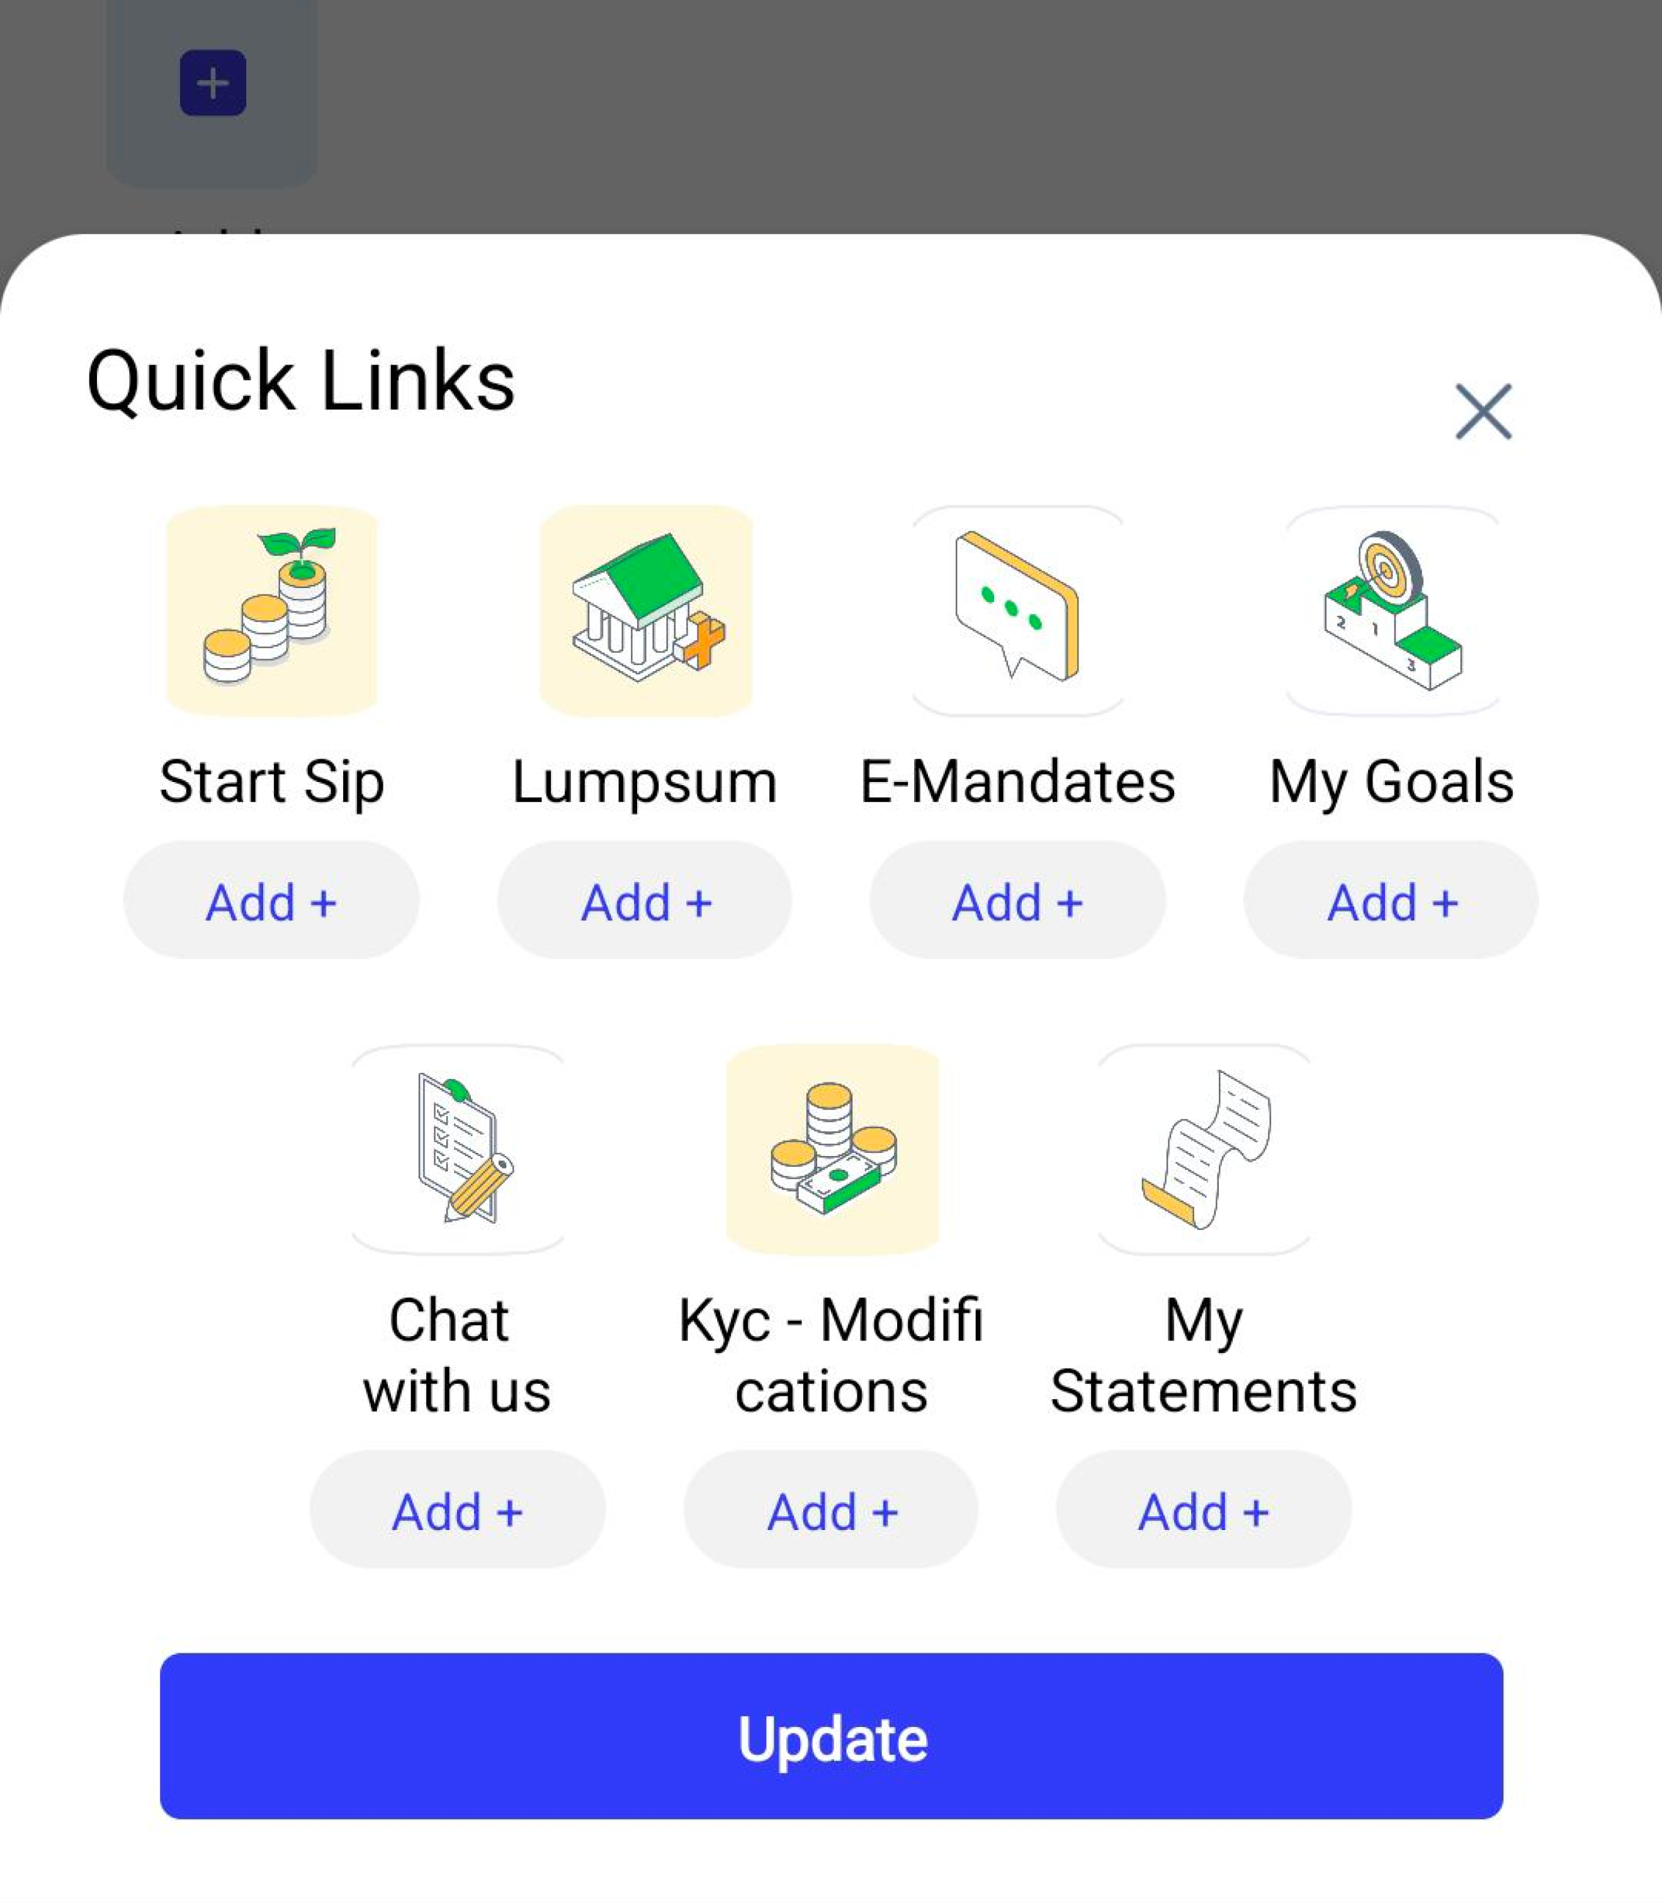

* CTA border radius is not same like design
* Text of Quick links and cross button is not aligned
* Take Modification word down
* Border is not looking proper in every icon

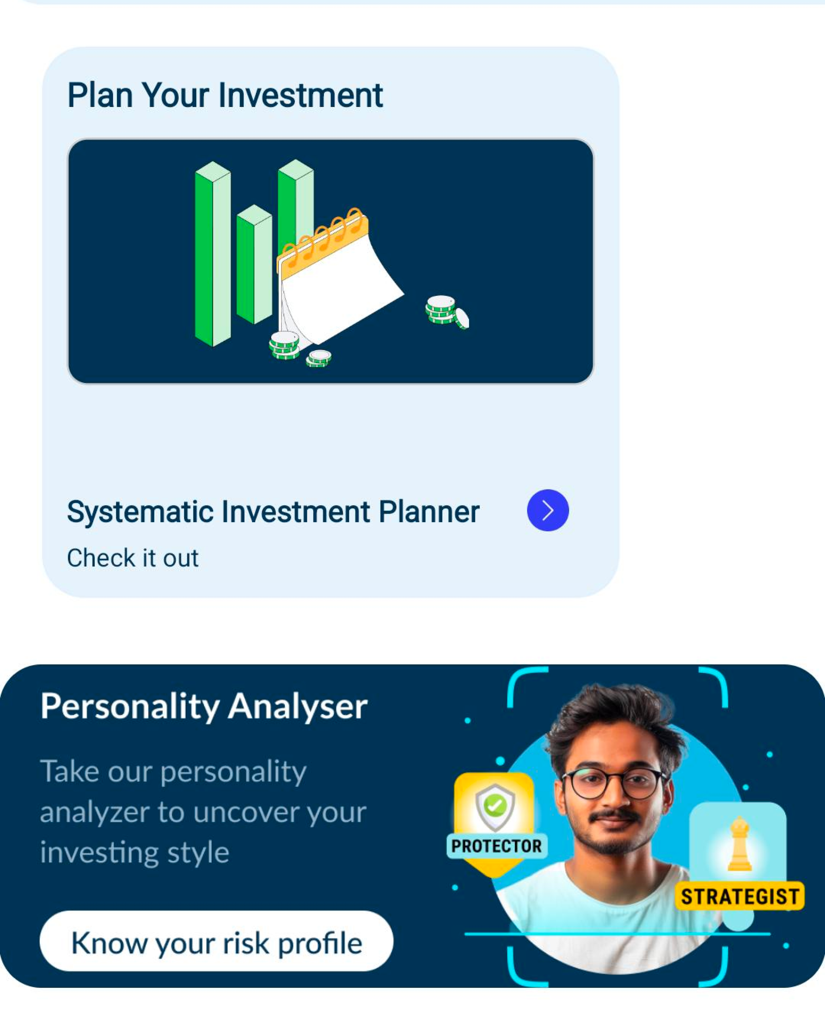

* Space above Systematic Investment Planner
* Banner should not be full length, check design

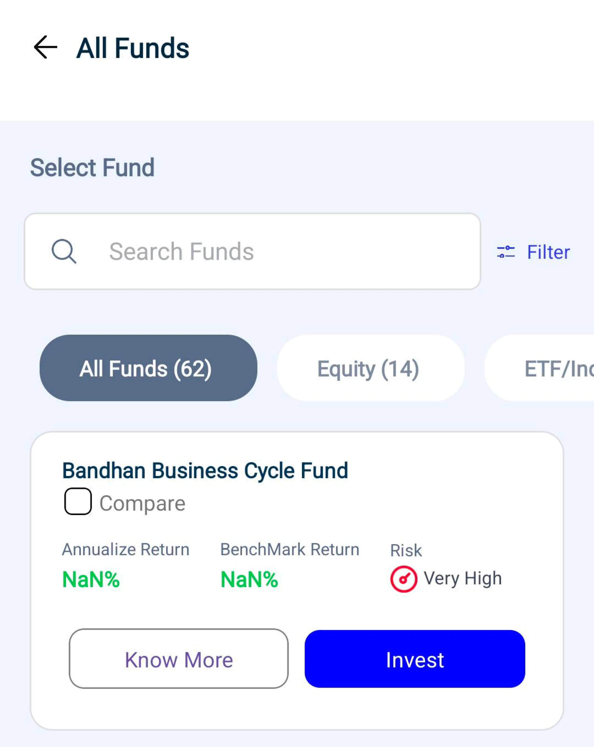

* Chip size is bigger, Keep same chip everywhere. Scheme card is not same like design
* CTA margin padding is perfect but keep everywhere the same
* Increase font size of scheme name



Logo should be center

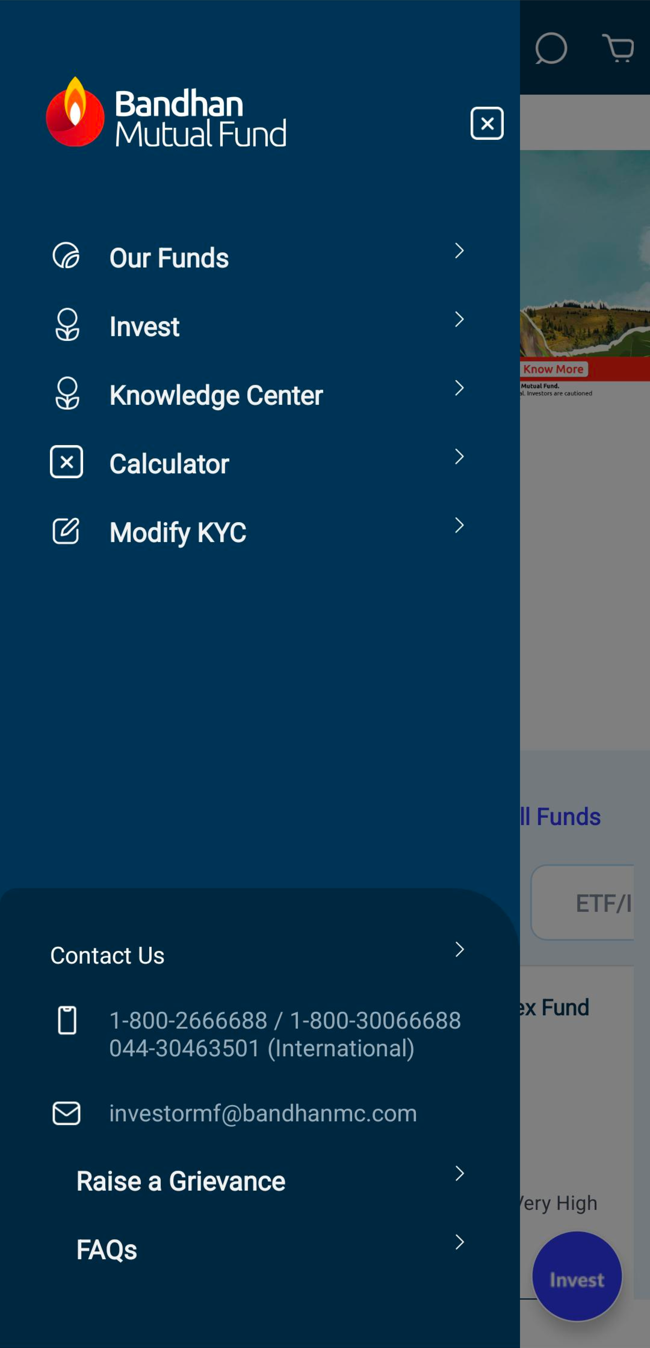

* Grid line is not followed properly
* Space between each section can be increased
* Cross button should come towards left

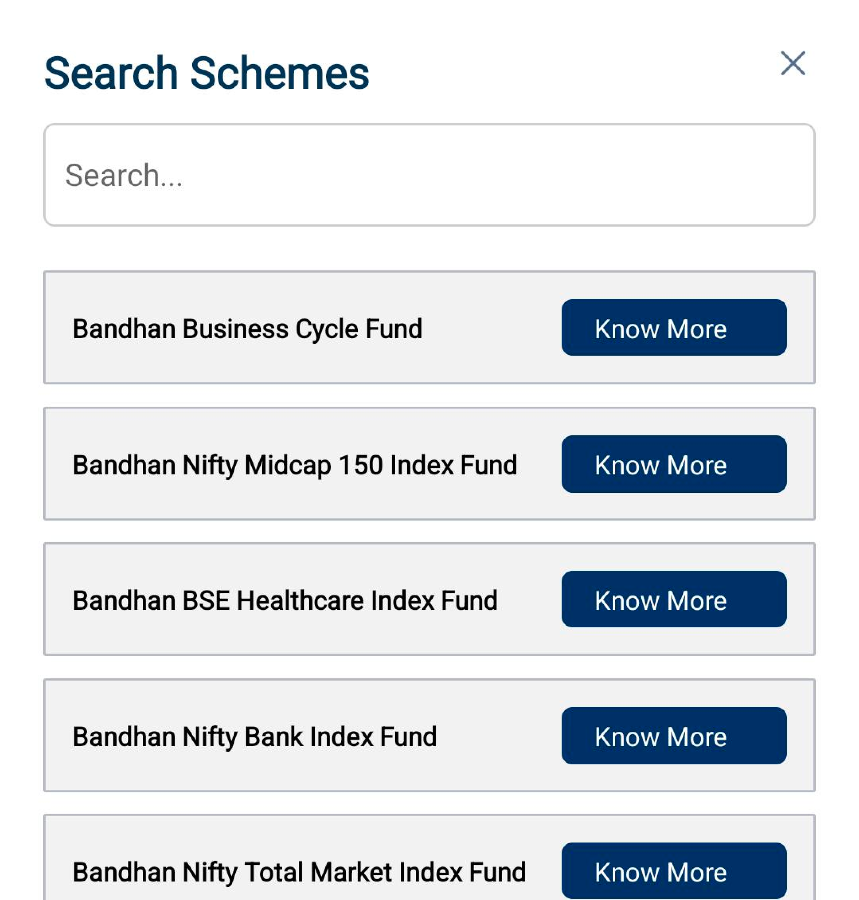

* Know more CTA is not proper
* Border radius of scheme name can be incresed and background of

grey should be white

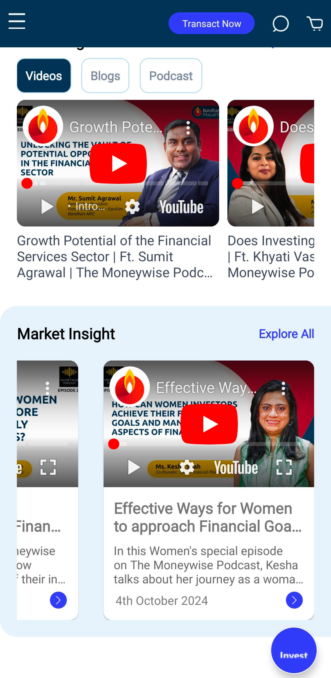

* Increase Space between chip and videos.
* follow the grid level.
* Make black color heading in market insight section
* Spacing between market insights card and Video card should be same